Task 1: Basic Class Hierarchy (Inheritance)
class Vehicle:
def __init__(self, brand, fuel_type):
# Initialize attributes
self.brand = brand
self.fuel_type = fuel_type
class Car(Vehicle):
def __init__(self, brand, fuel_type, num_doors):
# Call parent constructor
super().__init__(brand, fuel_type)
# Initialize additional attribute
self.num_doors = num_doors
# Test case
car1 = Car("Toyota", "Petrol", 4)
print("Task 1 Output:")
print(car1.brand, car1.fuel_type, car1.num_doors)
print()
Result:
This task demonstrates inheritance and reuse of parent class attributes which is one of the core concepts of object-oriented programming to support hierarchical relationships and code reuse.
(Lott, 2024; Downey, 2024).
Figure 1: Basic Class Hierarchy (Inheritance) Test Case Result
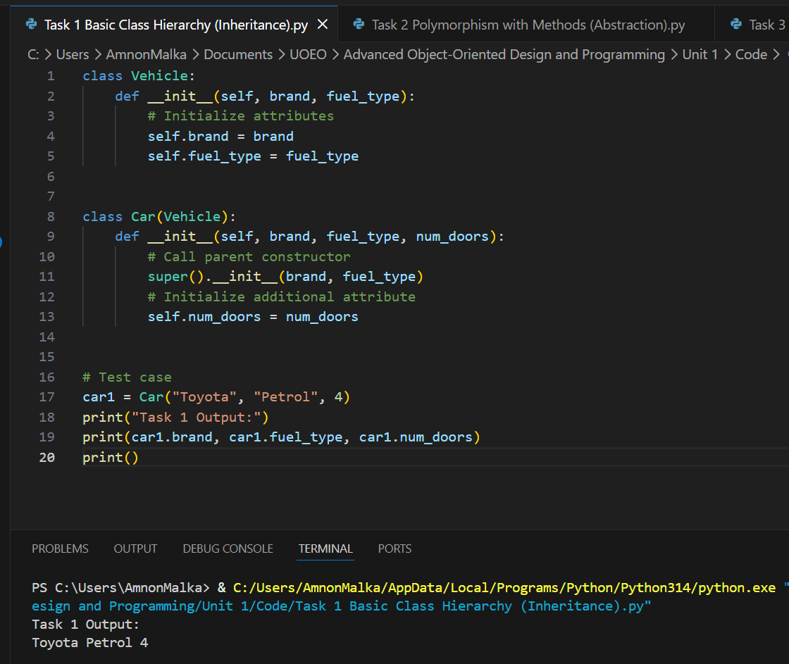

Task 2: Polymorphism with Methods (Abstraction)
from abc import ABC, abstractmethod
import math
class Shape(ABC):
@abstractmethod
def area(self):
pass
class Circle(Shape):
def __init__(self, radius):
self.radius = radius

def area(self):
return math.pi * (self.radius ** 2)
class Rectangle(Shape):
def __init__(self, length, width):
self.length = length
self.width = width
def area(self):
return self.length * self.width

# Test case
shapes = [Circle(5), Rectangle(4, 6)]
print("Task 2 Output:")
for shape in shapes:
print(shape.area())
print()
Result:
The results had demonstrated polymorphism in action that adapted to condition using same method name, different behavior and that supported cleaner code employing abstraction in action.
Figure 2: Polymorphism with Methods (Abstraction) Test Case Result
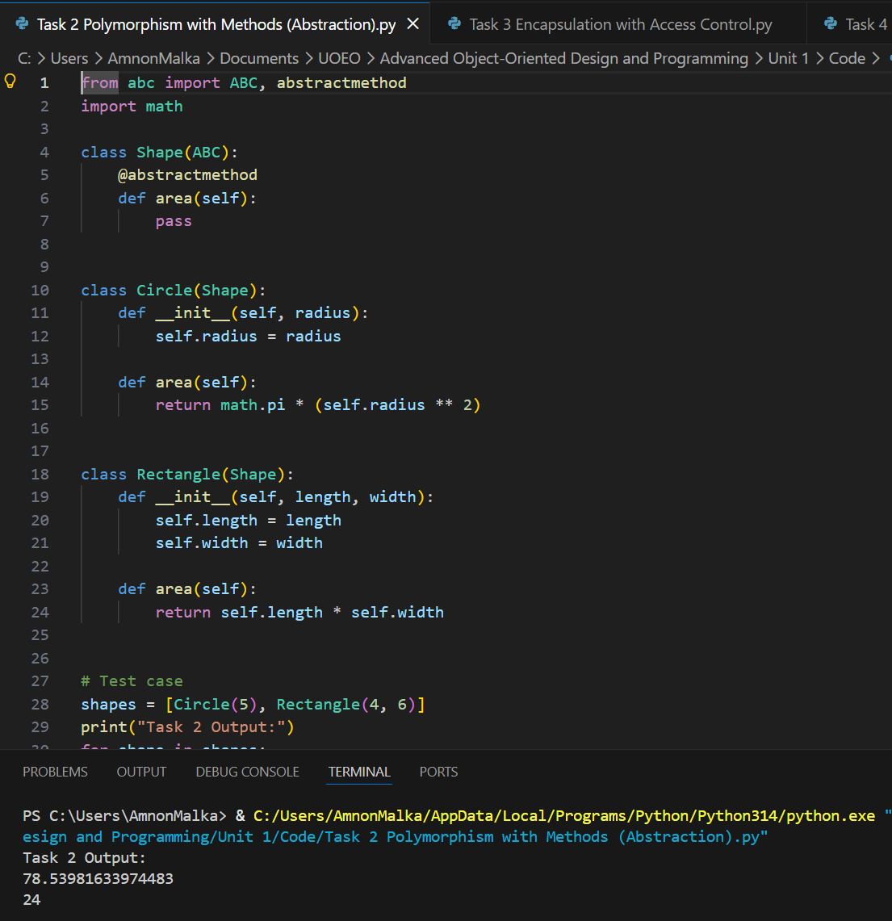

Task 3: Encapsulation with Access Control
class BankAccount:
def __init__(self, initial_balance=0):
# Private attribute
self.__balance = initial_balance
def deposit(self, amount):
if amount > 0:
self.__balance += amount
def withdraw(self, amount):
if amount <= self.__balance:
self.__balance -= amount
else:
print("Insufficient funds")
def get_balance(self):
return self.__balance
# Test case
acc = BankAccount(100)
acc.deposit(50)
acc.withdraw(30)
print("Task 3 Output:")
print(acc.get_balance())
print()
Result:
Result had demonstrated encapsulation in action with the use of private attributes (__balance) and ensuring legitimate and controlled access to data hence protecting internal object state as intended.
(Lott, 2024).
Figure 3: Encapsulation with Access Control Test Case Result
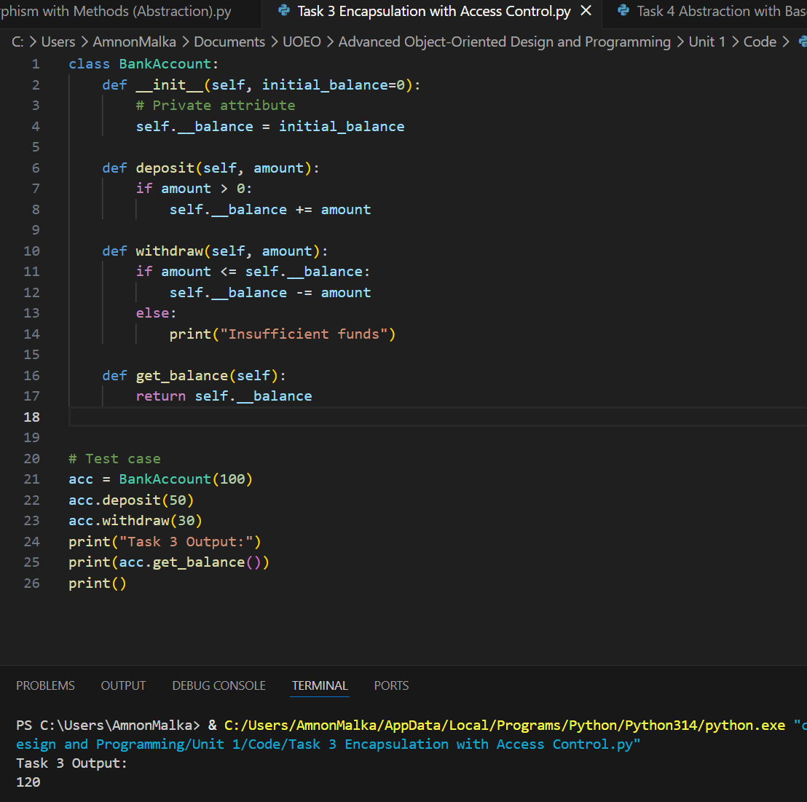

Task 4: Abstraction with Base Class
from abc import ABC, abstractmethod
class Animal(ABC):
@abstractmethod
def make_sound(self):
pass
class Dog(Animal):
def make_sound(self):
return "Woof!"
class Cat(Animal):
def make_sound(self):
return "Meow!"

# Test case
animals = [Dog(), Cat()]
print("Task 4 Output:")
for animal in animals:
print(animal.make_sound())
print()

Result:
Result had demonstrated abstraction in action with uniform interface design using abstract base classes which enforce method implementation in derived classes.
(Lott, 2024).
Figure 4: Abstraction with Base Class Test Case Result
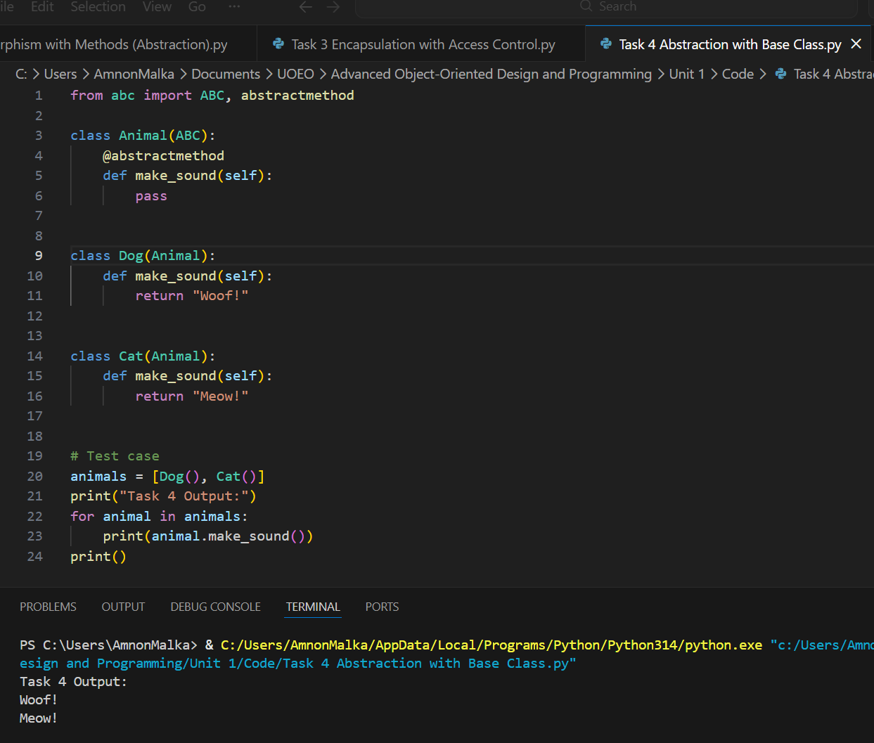

Task 5: Constructor and Destructor
class Person:
def __init__(self, name):
# Initialize name
self.name = name
print(f"{self.name} has been created.")

def __del__(self):
# Destructor message
print(f"{self.name} has been deleted. Goodbye!")

# Test case
print("Task 5 Output:")
p = Person("Alice")
del p

Result:
The results had demonstrated an object lifecycle management in action using constructors and destructors that handle the required initialization and cleanup of objects.
(Downey, 2024).
Figure 5: Constructor and Destructor
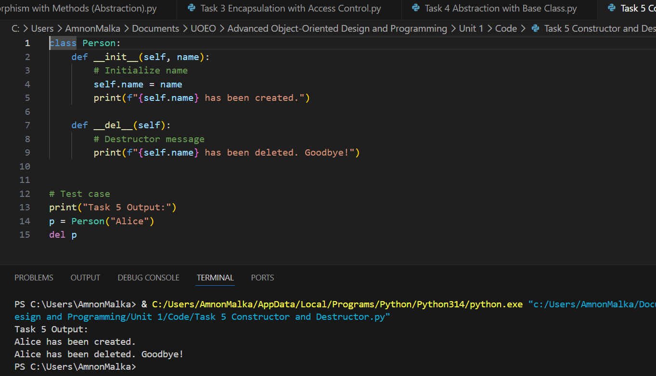

Concept Summary
Inheritance promotes code reuse while it also supports clean and structured code, Polymorphism delivers adaptable and extensible interfaces, while it helps improve hygiene, Encapsulation protects data and improves security. It does so by controlling unauthorized access. Abstraction improves simplicity, it enforces a structured approach. These principles are essential for creating scalable, maintainable, and secure systems, particularly in large-scale software engineering, where complexity introduces an extremely negative impact.
(Lott, 2024).

References
- Downey, Allen. Think Python. Third edition. Sebastopol, CA: O’Reilly Media, Inc., (2024) Print. Available at: https://essex.primo.exlibrisgroup.com/permalink/44UOES_INST/1b6ojm7/alma991008699515607346 [Accessed: 30 April 2026].
- Lott, Steven F. Modern Python Cookbook: 130+ Updated Recipes for Modern Python 3. 12 with New Techniques and Tools. 3rd ed. Birmingham: Packt Publishing, Limited, (2024). Print. Available at: https://essex.primo.exlibrisgroup.com/permalink/44UOES_INST/s7iv0e/cdi_proquest_ebookcentral_EBC31571566 [Accessed: 29 April 2026].

Use of Digital Tools
This document has been produced exclusively for educational purposes. Referenced content, copyrights, and trademarks, remain the sole property of the respective owner. ChatGPT 5.5 was used for some proofreading and clarity as well as literature exploration, language refinement, coding and programming techniques research. All academic writing, analysis, argumentation, and conclusions represent the original work of the author. AI tools were used for exploration, same way as academic literature exploration. No AI-generated content or code was directly copied into the final submission. Any use of content mentioned in this document is properly referenced to its original author and was used responsibly to ensure integrity and originality. All academic writing, analysis, argumentation, and conclusions represent my original work. I have used Artificial Intelligence responsibly and ethically, in accordance with the assignment brief. All AI use has been declared and evidenced.

